**ajax基础练习**

一、设计一个介绍英雄联盟英雄的详细信息的动态网页

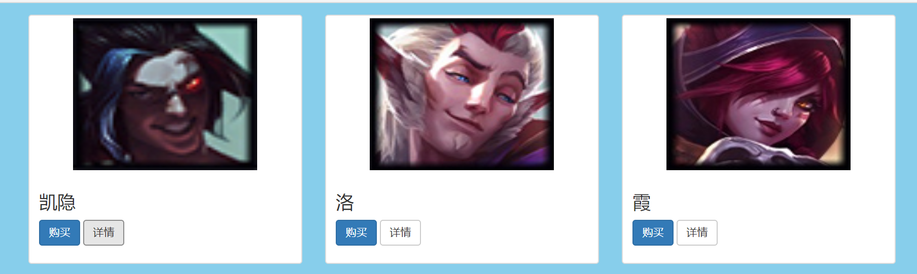

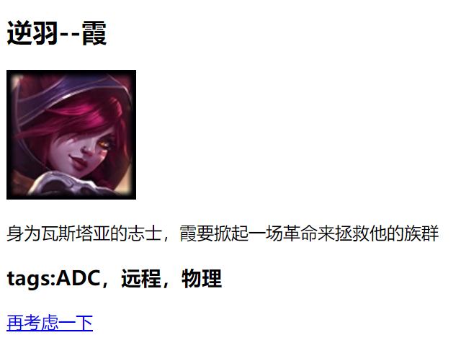

简单的做了一下，同学们可以参考一下，点“详情”可以跳转到详细页面

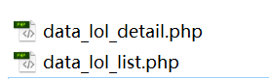这两个文件是配套的

代码：

hero_dis.php

<!DOCTYPE html>

<html>

<head>

<meta charset="utf-8" />

<title></title>

<style>

*{

margin:0px;

padding: 0px;

}

a{

text-decoration: none;

}

ul{

list-style: none;

}

li{

float:left;

}

body{

background: #F7F8F8;

}

.left{

float:left;

}

.right{

float:right;

}

/*底层最小大小*/

.bottomdiv{

min-width: 1238px;

margin-top: 30px;

}

.widthdiv{

width:1238px;

margin:0 auto;

overflow: hidden;

}

.herodiv{

width: 100%;

border-right: 1px solid #e8e8e8;

border-left: 1px solid #e8e8e8;

border-top: 1px solid #D7D7D7;

box-sizing:content-box;

background: #FFFFFF;

}

.herotitleul{

width: 100%;

background: #F0F0F0;

overflow: hidden;

}

.herotitleul li{

width: 160px;

height: 53px;

text-align: center;

}

.herotitleul li a{

display: inline-block;

line-height: 53px;

color: #00a383;

}

.herotitleul .active{

background: #ffffff;

border-top: 3px solid #00a383;

}

.herotxdiv{

width: 100%;

padding: 30px 37px 0px 30px;;

box-sizing: border-box;

}

.herotxul{

padding-left:20px;

width: 100%;

overflow: hidden;

}

.herotxul li{

width: 150px;

height: 200px;

text-align: center;

margin-bottom: 22px;

cursor: pointer;

margin-right: 15px;

}

.herotxul li img{

width: 150px;

height: 130px;

}

.herotxul li div{

text-align: left;

height: 35px;

overflow: hidden;

line-height: 35px;

}

.herotxul li div font{

font-size: 16px;

}

.herotxul li span{

display: inline-block;

font-size: 12px;

color: white;

display: inline-block;

height: 28px;

line-height: 28px;

text-align: center;

border-radius: 5px;

width: 45px;

}

.herotxul li span:first-child{

background: #337AB6;

}

.herotxul li span:last-child{

background: #F5EDED;

color: black;

border-color: #000000;

}

</style>

<script type="text/javascript" src="js/jquery.js" ></script>

</head>

<body>

<div class="bottomdiv">

<div class="widthdiv">

<div class="herodiv">

<ul class="herotitleul">

<li class="active"><a>英雄</a></li>

<li><a>物品</a></li>

<li><a>召唤师技能</a></li>

<li><a>符文</a></li>

<li><a>云顶之弈</a></li>

</ul>

<div class="herotxdiv">

<ul class="herotxul">

<?php

include 'data_lol_list.php';

$dan = "'";

for($i = 0; $i < count($heroArr); $i++)

{

echo '<li onclick="clickli('.$dan.$heroArr[$i]['champion_name'].$dan.')">

<img src="'.$heroArr[$i]['champion_icon'].'">

<div>

<font>'.$heroArr[$i]['champion_name'].'</font>

</div>

<div>

<span>购买</span>

<span>详情</span>

</div>

</li>';

}

?>

</ul>

</div>

</div>

</div>

</div>

<!--用form的input hidden 保存索引值-->

<form name="frm" action="hero_deatil.php" method="get">

<input type="hidden" name="heroname"/>

</form>

<script>

// 需要做的是 点击头像，将id赋予text，再提交表单

function clickli(name){

document.getElementsByName("heroname")[0].value = name;

document.frm.submit();

}

</script>

</body>

</html>

hero_deatil.php

<!DOCTYPE html>

<html>

<head>

<meta charset="UTF-8">

<title></title>

<style>

.ptitle{

font-size: 24px;

color: #338c7a;

font-weight: bold;

margin-bottom: 10px;

}

.hero1{

height: 100%;

word-break:break-all;

font-size: 14px;

line-height: 24px;

overflow: hidden;

}

.hero2{

font-size: 19px;

font-weight: bold;

}

</style>

</head>

<body>

<div>

<p class="ptitle">英雄简介</p>

<?php

include 'data_lol_detail.php';

$name = $_GET['heroname'];

echo

'

<p class="hero2">

'.$heroArr[$name]['champion_title'].'--'.$heroArr[$name]['champion_name'].'

</p>

<img src="'.$heroArr[$name]['champion_icon'].'">

<p class="hero1">

'.$heroArr[$name]['champion_info'].'

</p>

<p class="hero2">

'.$heroArr[$name]['champion_tags'].'

</p>

<p>

<a href="hero_dis.php">再考虑一下</a>

</p>

'

?>

</div>

</body>

</html>

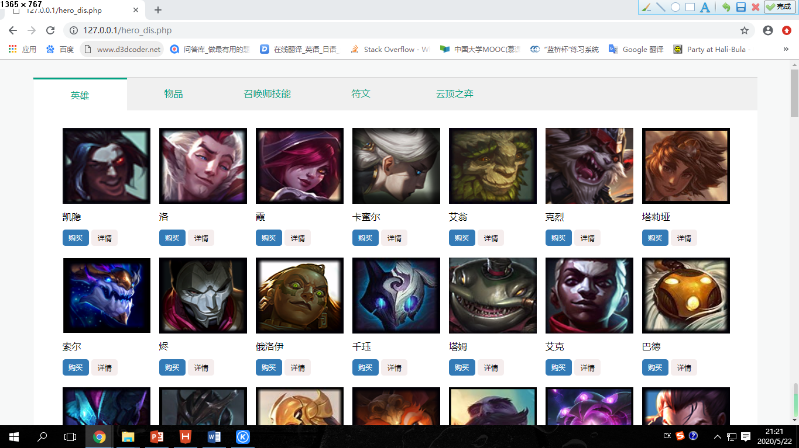效果图：

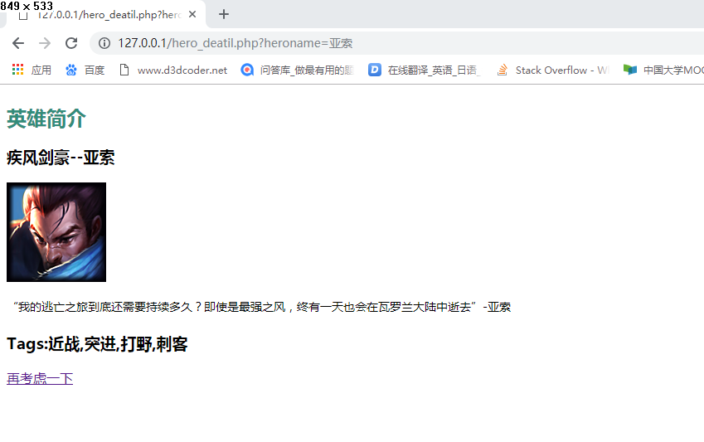

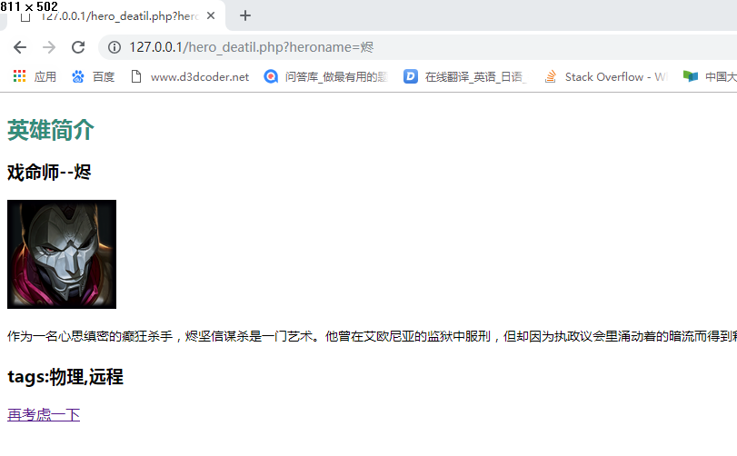

二、设计一个上传英雄联盟头像图片的网页

代码：

uploadheroimg.html

<!DOCTYPE html>

<html>

<head>

<meta charset="UTF-8">

<title></title>

</head>

<body>

<form action="getheroimg.php" method="post" enctype="multipart/form-data" onsubmit="return isfile(this);">

<p>请选择你要上传的英雄头像</p>

<p><input type="file" name="files" /></p>

<p><input type="submit" value="提交"/> </p>

</form>

<script>

function isfile(frm){

var f = frm.files.value;

if(f == ""){

alert("请选择头像文件");

return false;

}else{

return true;

}

}

</script>

</body>

</html>

getheroimg.php

<!DOCTYPE html>

<html>

<head>

<meta charset="UTF-8">

<title></title>

<style>

p{

font-size: 16px;

color:#00a383;

font-weight: bold;

}

font{

font-size: 15px;

color: black;

font-weight: 0;

}

</style>

</head>

<body>

<?php

$upfile = $_FILES['files'];

// 保存至临时文件

move_uploaded_file($upfile['tmp_name'], 'uploadfile/'.$upfile['name']);

?>

<p>你上传图片的名称：<font><?php echo $upfile['name'];?></font></p>

<p>你上传图片的大小：<font><?php echo $upfile['size'];?>kb</font></p>

<p>你上传图片的类型: <font><?php echo $upfile['type'];?></font></p>

<p>你上传的图片</p>

<img src="uploadfile/<?php echo $upfile['name'];?>" />

</body>

</html>

效果图：

